Seminar
The Actuarial Profession in the Context of Risk-Based Capital Solvency Regimes
Sarajevo, Bosnia & Herzegovina
November 2019

Day 1: Insurance Core Principles
09:30 –10:00 Registration
10:00 – 11:00 Introduction (welcome words, introduction of the speaker and participants, overview of the seminar program and Actuaries Without Borders)
11:00 – 11:30 Coffee Break
11:30–12:30 Introduction to Insurance Regulation and Insurance Core Principles
12:30 – 13:30 Lunch
13:30-14h30 Corporate Governance - 4 Internal Control Functions (ICP 7)
14h30-15h30 Risk Management and Internal Control Systems (ICP 8)
15:30 – 16:00 Coffee Break
16:00 –17h00 Case Study and Day Summary
20:00- 22:00 Seminar Dinner
Day 2 The Role of the Actuary and Risk Management
09:00 –10:30 Enterprise Risk Management for Solvency Purposes (ICP 16 including ORSA – Own Risk & Solvency Assessment, S&FCR- Solvency & Financial Condition Report & ISAP5 & ISAP6)
10:30- 11:00 Coffee Break
11:00-12:30 The Role of the Actuary in Risk-Based capital regimes
12:30 –13:30 Lunch
13:30-14:15 Actuarial Education – supporting the effectiveness of the profession
14:15- 15:15 Practical Exercise
15:15 – 15:30 Coffee Break
15:30-16:00 Summary and Conclusion
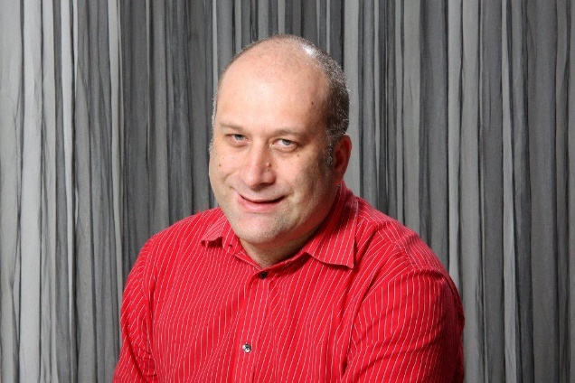
Speaker: Andrew Gladwin
Andrew Gladwin works in the Actuarial Control Function for Old Mutual, one of the largest insurers in Africa. He has been involved in a number of life insurers in the Old Mutual group across Africa, including being the Appointed Actuary for some of these insurers. He has worked with a number of insurance regulatory regimes, including engagement with regulators around regulatory capital changes. He was involved in setting up the mandate for the Actuarial Control Function at Old Mutual.
Andrew has been extensively involved in Actuarial Society of South Africa and IAA, especially in terms of education developments. This includes driving the development of an independent South African actuarial qualification, and chairing the Syllabus Review Task Force of the IAA which developed the updated core syllabus of the IAA. He is a current member of the IAA Education Committee as well as on the Board of the Life Section of the IAA.
Andrew has presented extensively around the world on technical topics, actuarial education and professionalism. He is passionate about the value that actuaries can add in a wide range of areas, and the importance of quality actuarial education balancing strong technical and professional skills.

